**HORMISDALLEN PRIMARY SCHOOL- KYEBANDO**

**MID TERM II EXAMINATION, 2015**

**P.1 LITERACY**

Name: ……………………………………………………………………………………………………………

School: ………………………………………………..………………..………… Stream:…………………

***SECTION A***

1. A ____________________________ is a place where we go to learn. (school home)

2. We use a ___________________________________ for sweeping.

(rag broom)

3. Name this object we use in the classroom.

|  |  |
| --- | --- |
| 🕮 |  |
|  |  |

4. Who cooks at home?

________________________________________________________________

5. Name this garden tool.

_________________________________________________

6. An ___________________________________ is a sudden happening on the body. (accident weather)

7. What do we call a place where we stay? (home school)

_________________________________________________________________

8. Name this place found in our community. (Mosque Church)

­__________________________________________________

9. What do we use for seeing?

_________________________________________________________________

10. Which animal guards our home?

_________________________________________________________________

11. Who teaches pupils at school? (teacher head teacher)

_________________________________________________________________

12. Draw a knife.

13. The daily condition of a day is called

_________________________________________. (Accident weather)

14. Who heads a family? (mother father)

________________________________________________________________

15. Why do we eat food? (die grow)

We eat food to _____________________________________________.

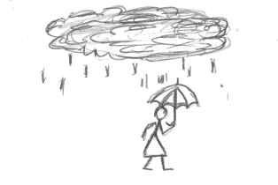16. Name this element of weather. (sun shine, rainfall)

_______________________________________________

17. Name the common accident below. (knocks, falls)

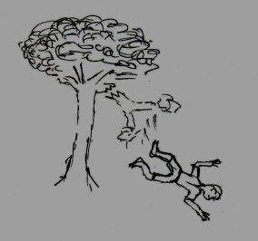

___________________________________________

18. Draw this person found at home.

|  |
| --- |
|  |
| baby |

19. Which basic need of people is this? (water, food)

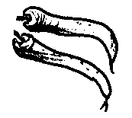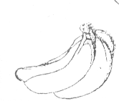

______________________________________

20. Why do we cut our finger nails short?

(To avoid germs, To get sickness)

_________________________________________________________________

***SECTION B***

21. **Match the people at school to their work**.

Teacher cooks food at school

Gateman heads the school

Cook closes and opens the gate

Head teacher teaches children at school

22. Name these people at home.

|  |  |  |  |
| --- | --- | --- | --- |
|  |  |  |  |
|  |  |  |  |

(baby father mother brother)

23. Draw these important places in our community.

|  |  |  |  |
| --- | --- | --- | --- |
|  |  |  |  |
| hospital | church | school | mosque |

24(a) _________________________________________ is the general cleanliness of the body. (Personal hygiene bathing)

(b) Name these things we use to clean the body.

|  |  |  |
| --- | --- | --- |
|  |  |  |
|  |  |  |

(sponge water soap)

25. Match the types of weather.

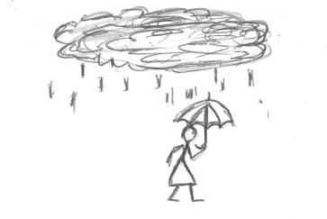

sunny

rainy

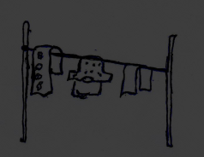

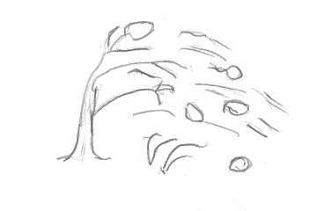 windy

cloudy

26. Draw these things which cause accident.

|  |  |  |  |
| --- | --- | --- | --- |
|  |  |  |  |
| fire | broken bottle | nail | razorblade |

27. **Match people at home to their roles**.

Mother heads a home

Father fetches water

Sister cooks food

Brother washes plates and cups

28. Name the parts of food we eat.

(roots fruit leaves stem)

Sugar cane: ____________________________________________

Cabbage: ____________________________________________

Cassava: ____________________________________________

Pawpaw: ____________________________________________

29. Name these activities done in our community.

(digging treating sick people teaching)

|  |  |  |
| --- | --- | --- |
|  |  |  |
|  |  |  |

30. Give the uses of the body parts below.

(seeing hearing walking smelling)

|  |  |  |  |
| --- | --- | --- | --- |
|  |  |  |  |
|  |  |  |  |

31(a) _______________________________ is the moving air. (rain wind)

(b) Draw a girl winnowing.

(c) Draw these uses of wind.

|  |  |
| --- | --- |
| i) Drying clothes | ii) Flying a kite |
|  |  |

32. Match the road signs.

zebra crossing

No parking

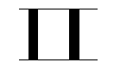

Parking

School a head

33. Complete the sentences. (house forest bush nest)

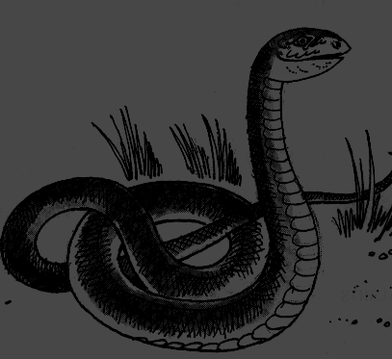 A snake stays in a ____________________________

A man stays in a ____________________________________

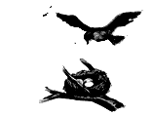

A bird stays in a __________________________________

A monkey stays in a ________________________

34. Name these common foods.

|  |  |  |  |
| --- | --- | --- | --- |
|  |  |  |  |
|  |  |  |  |

(cassava banana beans fish)

35(a) Draw the following uses of a sunny weather.

|  |  |
| --- | --- |
|  |  |
| Dries seeds | Dries clothes |

(b) Name the two seasons. (dry rainy wet cold)

(i) ____________________________________ season.

(ii) ____________________________________ season.